### **Inventory Management Using IBM Cognos Analytics**

**Submitted by**

**Kushagra Bajpai**

**19BAI10053**

**Submitted to**

**Respected Uma Rani Mam**

**Steps to be followed with respective screenshots of the tasks**

**>> Create And Login to IBM Account**

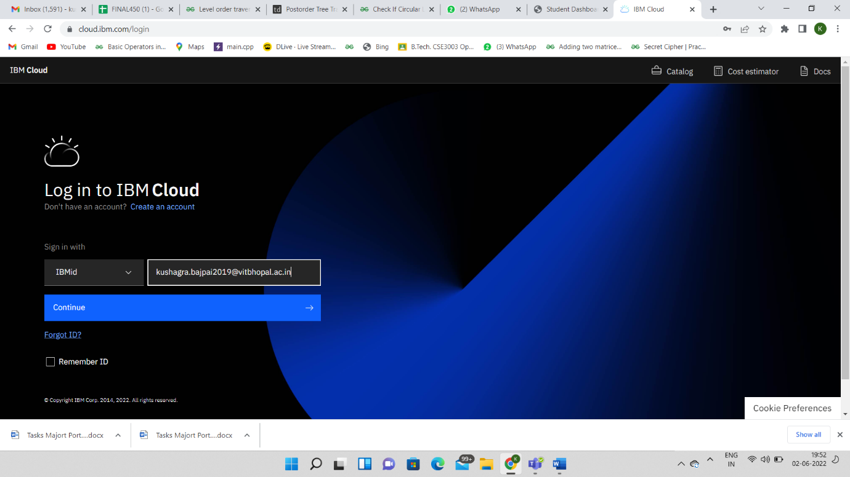

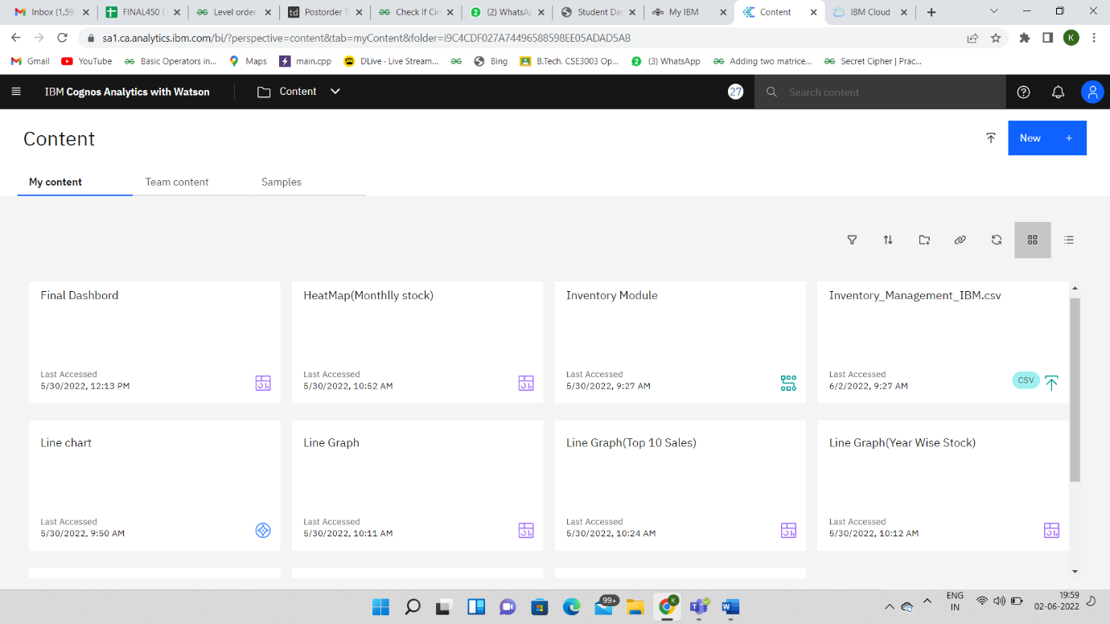

**>> Loading the Dataset**

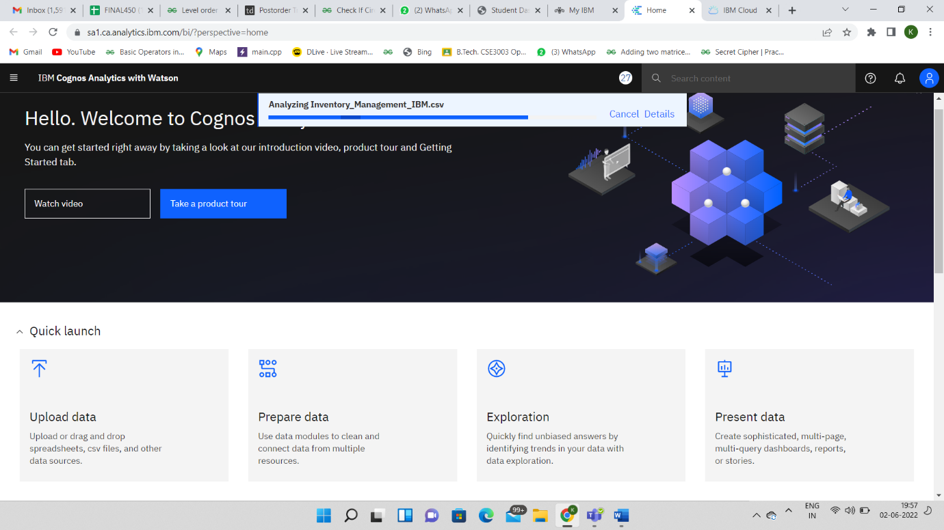

**>> Prepare the Dataset**

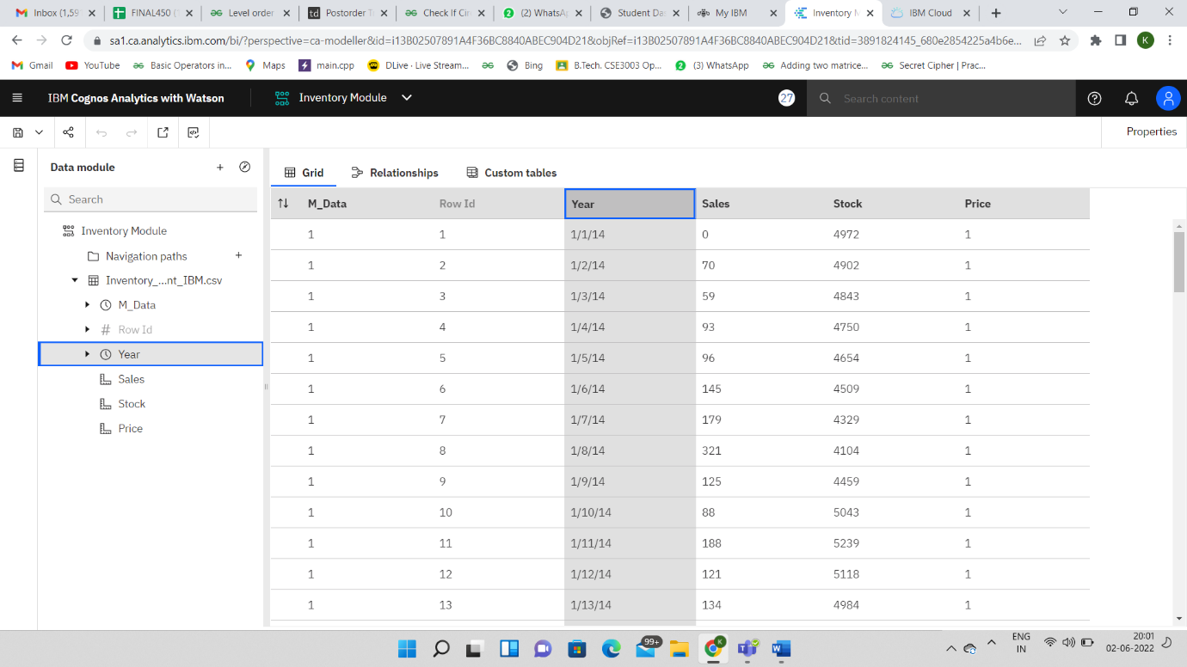

**>> Prepare Calculations**

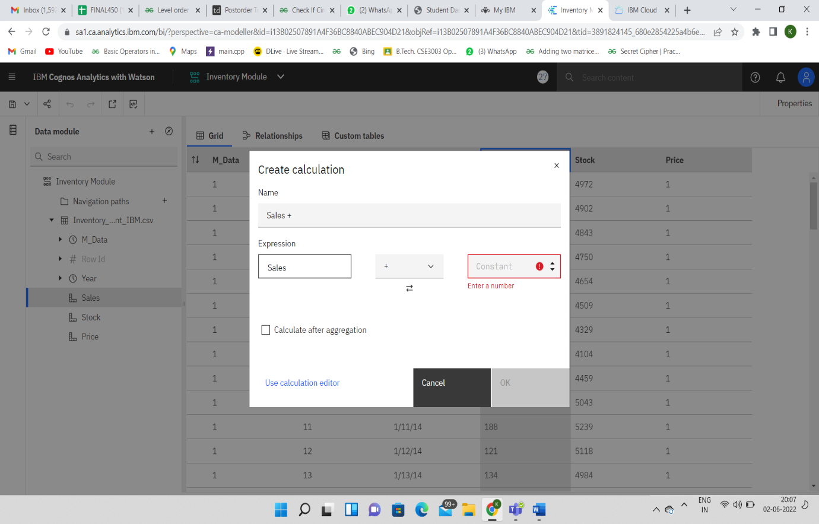

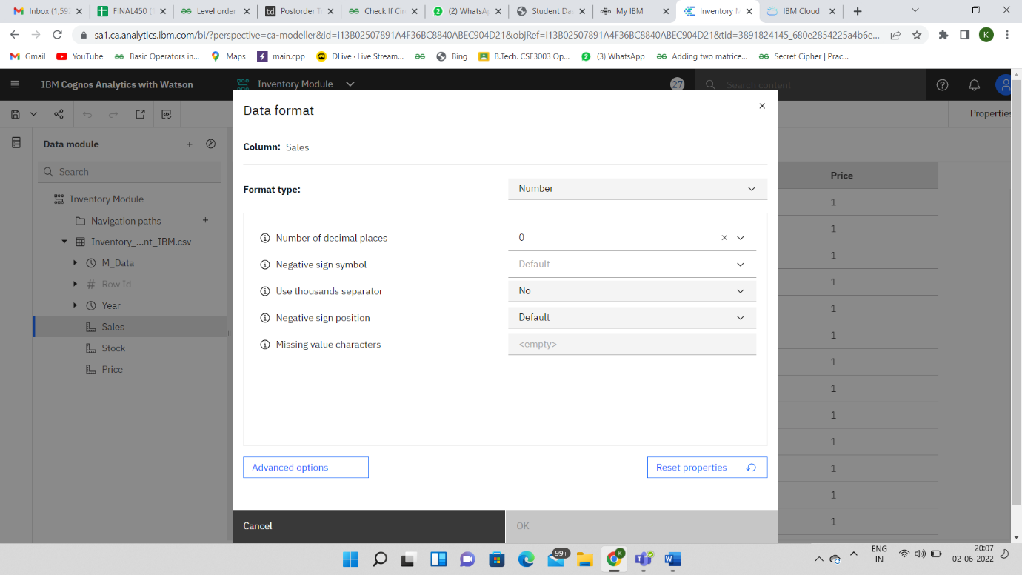

**>> Data Visualization Charts**

* **Year Wise Price Using Line Graph**

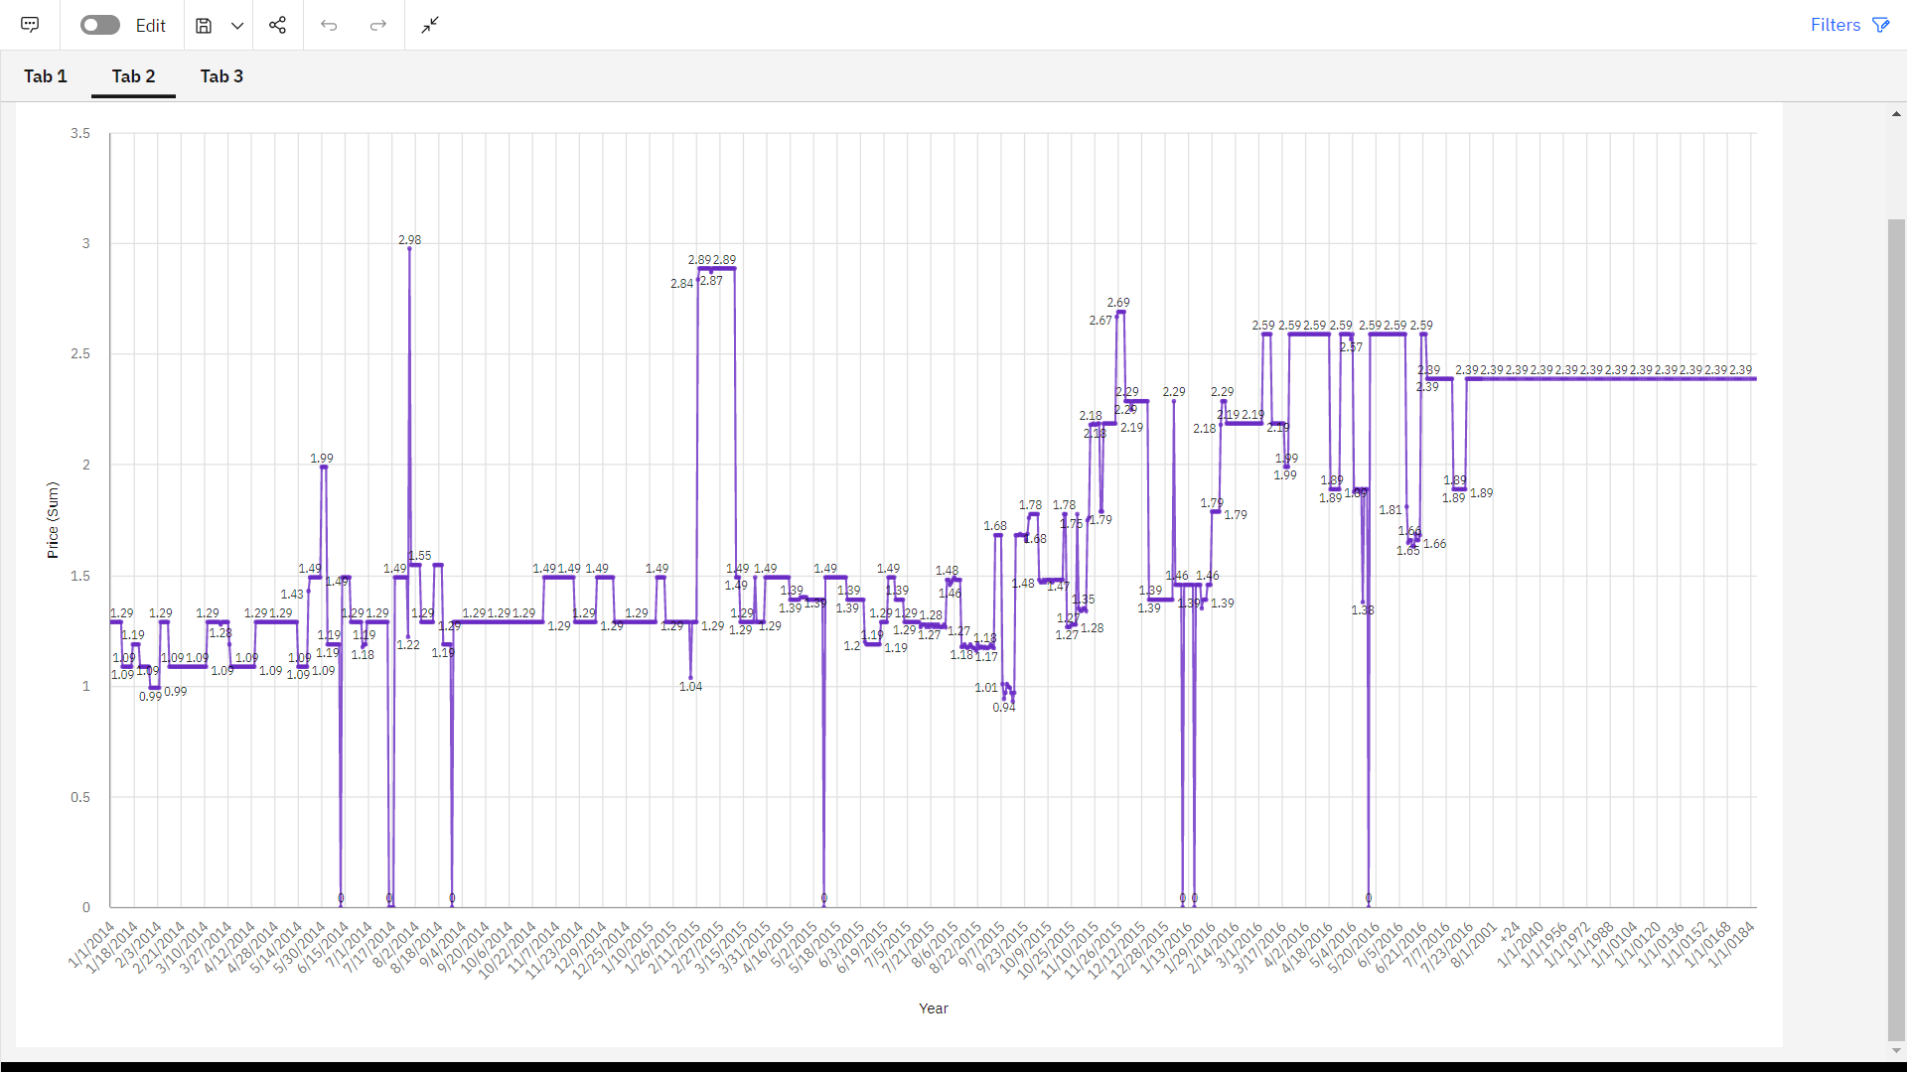

* **Year Wise Stock Using Line Graph**

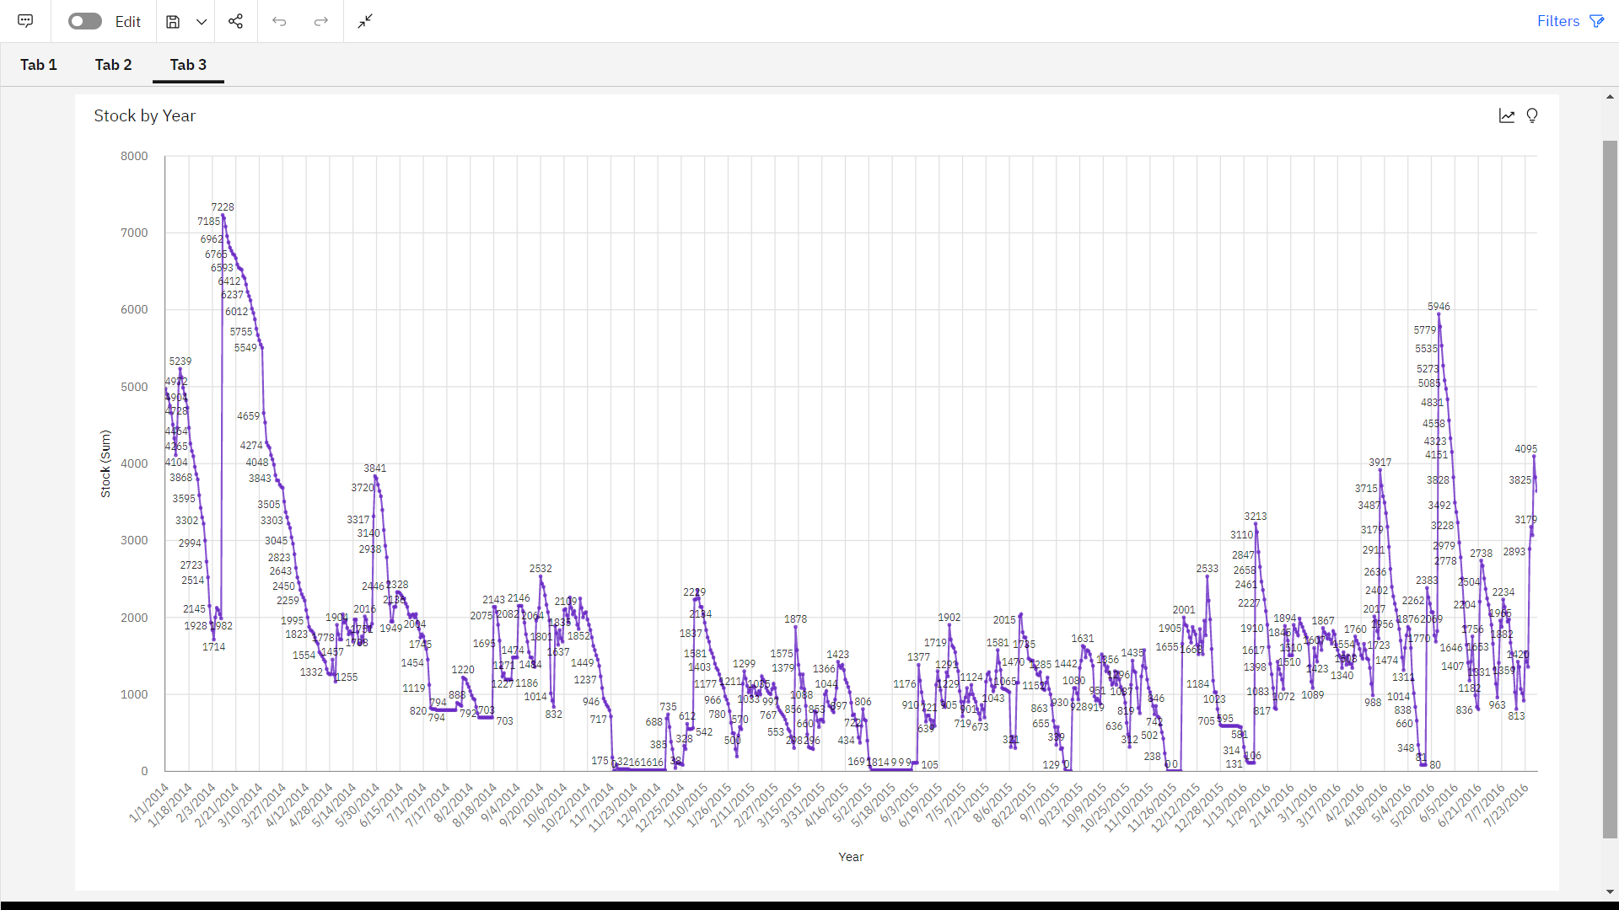

**Top10 Sales By Year Using Line Graph**

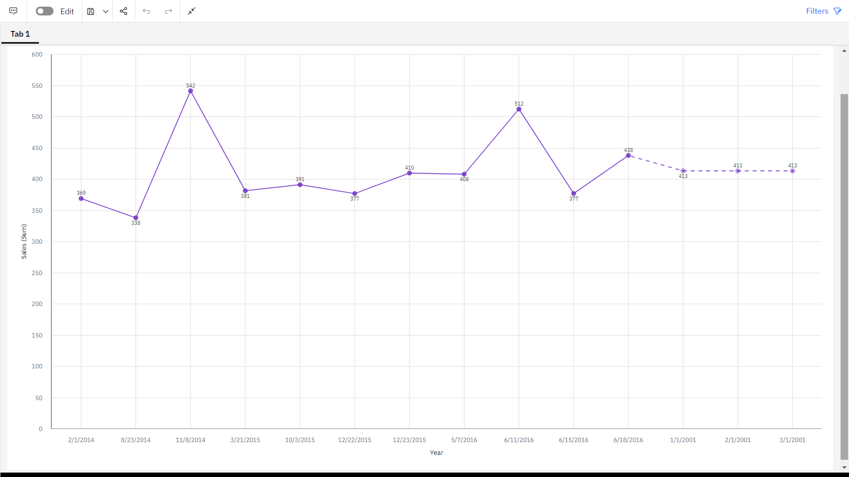

* **Monthly Stock Using Heat Map**

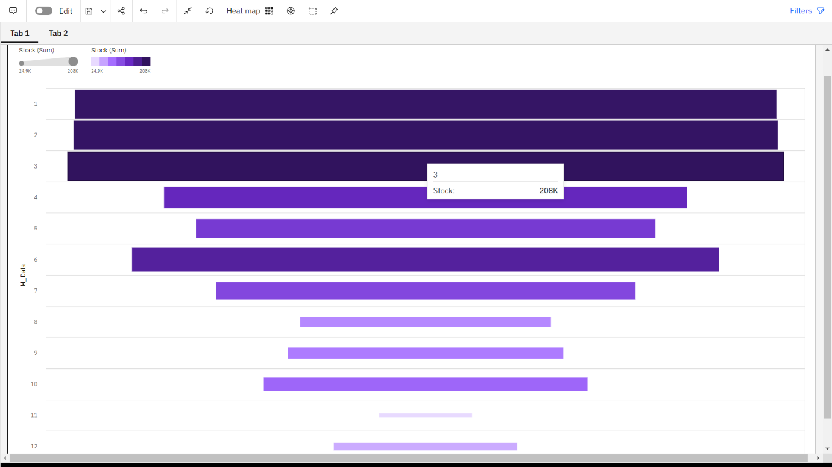

* **Monthly Sales Using Tree Map**

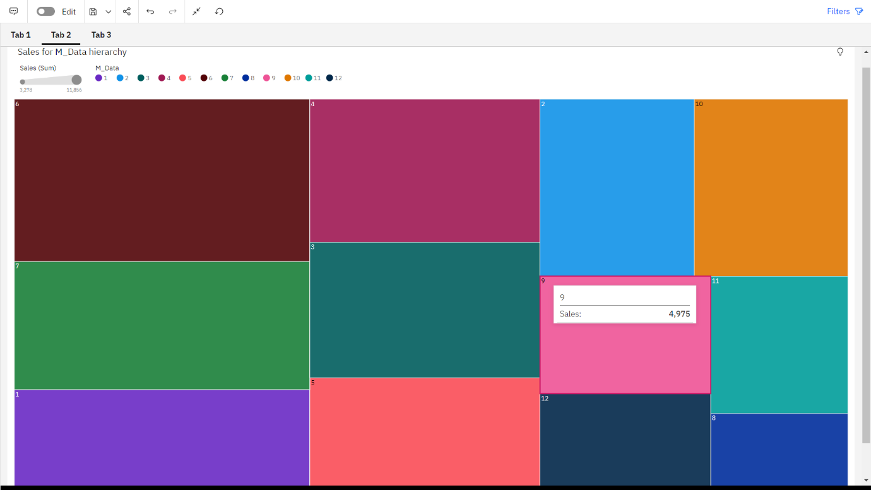

* **Monthly Price by Pie Chart**

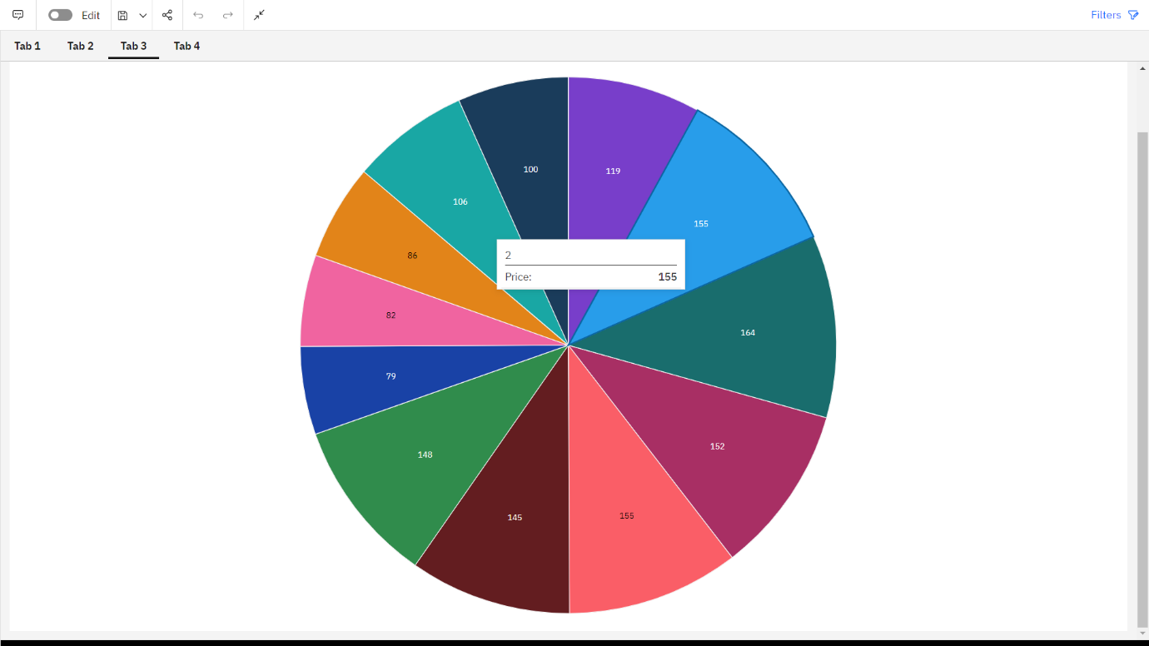

* **Revenue by Year**
* 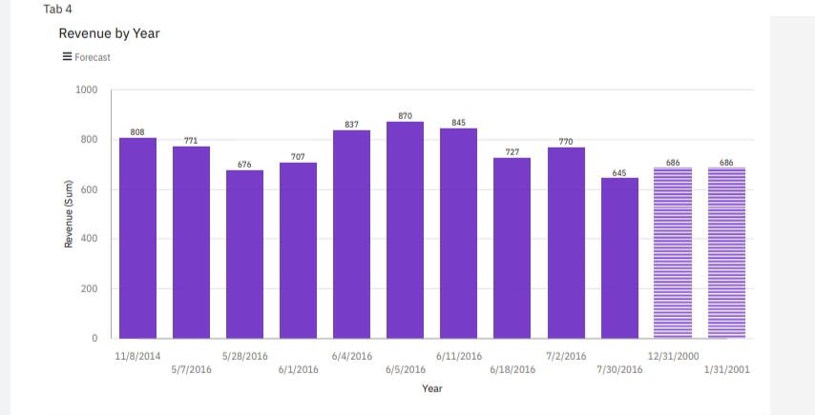
* **Summary Cards of Total Revenue, Sales, Stock, Price**

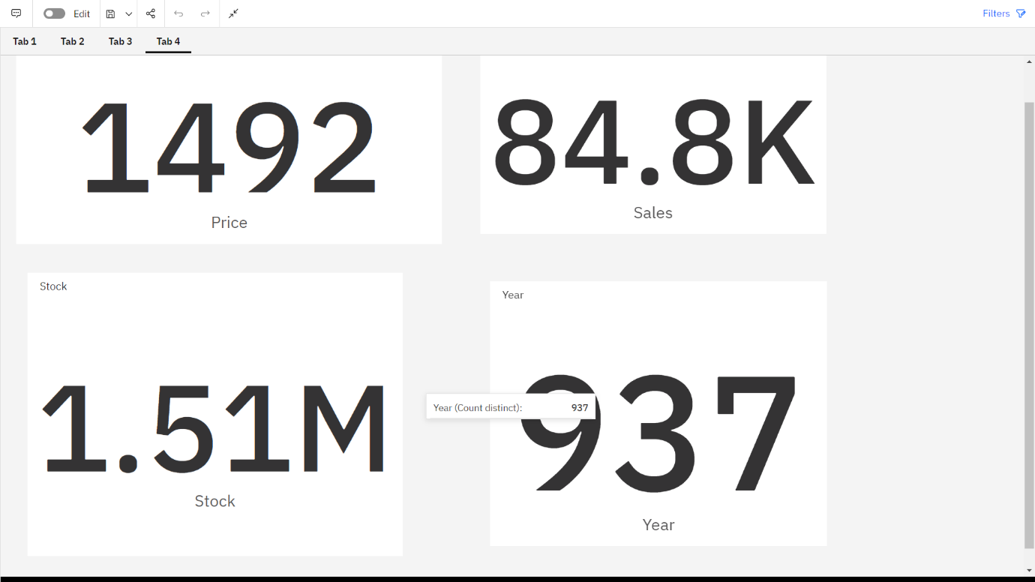

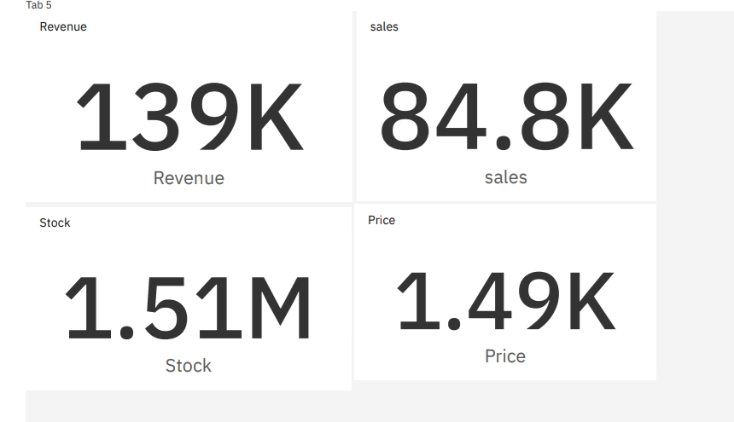

* **Dashboard Creation**

